TELCO CUSTOMER CHURN PREDICTION

ABSTRACT:
Customer attrition or churn, is when customers stop doing business with a company. It can have a significant impact on a company's revenue and it's crucial for businesses to find out the reasons why customers are leaving and take steps to reduce the number of customers leaving. One way to do this is by identifying customer segments that are at risk of leaving, and implementing retention strategies to keep them. Also, by using data and machine learning techniques, companies can predict which customers are likely to leave in the future and take actions to keep them before they decide to leave. The dataset used in this study consists of Senior Citizen, Partner, Dependents, tenure, Phone Service, Multiple Lines, Internet Service, Online Security, Online Backup, Device Protection, Tech Support, Streaming TV, Streaming Movies, Contract, Paperless Billing, Payment Method, Monthly Charges, Total Charges, Churn status. Leveraging this dataset, we employ various machine learning algorithms to build a predictive model for customer churn. To address this classification problem, we compare the performance of multiple algorithms such as Logistic Regression, Decision Tree Classifier, Random Forest, Support Vector Classifier and KNN Classifier. Through thorough evaluation and comparison, we identify the most suitable algorithm that provides the highest accuracy and generalizability for customer churn prediction.

I. INTRODUCTION

In today's fiercely, retaining is a top priority for sustaining profitability and market relevance. Telco Customer Trades Prediction has emerged as a critical tool to address this challenge. Trades, the loss of to contestants or service termination, can significantly impact a telco company's bottom line. and preventing customer Trades through data-driven has come essential. This project es on the predictive power of data analytics and in the telco sector. We aim to develop accurate that anticipate customer Trades, allowing telecom providers to take proactive measures to retain valuable subscribers. By customer data, usage patterns, and variables, we seek to identify the factors contributing to Trades and predict which clients are most likely to leave.
Our research delves into cutting-edge, feature engineering and progressive procedures, to optimize Trades prediction accuracy. This project's ultimate goal is to equip telco companies with the insights needed to reduce Trades rates, enhance customer satisfaction, and ensure long-term success in a rapidly evolving market.
The telecommunications (telco) industry stands as a cornerstone of modern society, enabling seamless communication and connectivity. However, within the sprawling telco landscape, an ever-persistent challenge looms - customer turnover, colloquially known as "churn." In recent years, this phenomenon has taken center stage in the strategic agendas of telco providers, for it poses a significant threat to their sustainability and profitability. This introduction delves into the theoretical underpinnings of customer turnover in the telco sector, illuminating the crucial context for the subsequent project.
  - The Dynamics of the Telco Industry
The telecommunications (telco) industry is a dynamic and ever-evolving sector, where technological advancements, changing market forces, and evolving consumer demands continually shape the landscape. Amidst fierce competition among multiple service providers, the industry faces the challenges of customer churn, making it a formidable adversary that can erode market share, revenue, and profitability. Factors such as mobile number portability, regulatory changes, and the emergence of 5G technology have heightened the battle for customer loyalty, emphasizing the need for telco companies to remain innovative and customer-focused. To thrive in this environment, telco firms must adapt swiftly, leveraging cutting-edge technologies and customer-centric strategies to retain and attract subscribers, ultimately securing their position in this fast-paced and dynamic industry.
1.2 Understanding Customer Churn
Customer churn, simply put, refers to the phenomenon where customers terminate their subscriptions or switch to a different telco provider. This attrition is often triggered by a myriad of factors, including but not limited to:
- Service Quality: In today's highly competitive telecommunications industry, customer expectations for top-notch service quality are paramount. Consumers demand nothing less than seamless connectivity and high-quality services, and any deviations from this standard can swiftly result in dissatisfaction and, consequently, customer churn. In an era where connectivity is the lifeblood of modern society, network disruptions, sluggish data speeds, or unreliable coverage can disrupt daily routines, hinder productivity, and frustrate customers. Telco providers must maintain robust and resilient networks, invest in infrastructure, and continually improve service quality to meet these expectations. Failing to deliver on these fronts not only risks customer attrition but also damages a company's reputation and competitiveness in a market where service excellence is a non-negotiable requirement.
- Price Sensitivity: In the fiercely competitive landscape of the telecommunications industry, price sensitivity is a pervasive and potent factor that significantly influences customer behavior. With numerous providers vying for their business, customers have become increasingly attuned to cost considerations. This heightened price sensitivity prompts consumers to frequently explore alternative providers in pursuit of better deals, cost savings, or more attractive pricing plans. The ease of switching in today's market, often facilitated by mobile number portability, means that customer loyalty is more tenuous than ever. Telco companies must continuously balance the need for competitive pricing with the imperative to maintain profitability and invest in infrastructure and innovation, making pricing strategy a pivotal element in their efforts to retain and attract customers in this highly dynamic and cost-conscious environment.
- Customer Service: The role of customer service cannot be overstated, as it wields a considerable influence on customer retention and satisfaction. Poor customer service experiences, characterized by lengthy wait times, unresolved issues, or unhelpful support, can swiftly drive customers away. In an era where communication is a lifeline for both personal and professional purposes, customers expect responsive, efficient, and effective support. Disappointments in this regard not only lead to frustration but also erode trust in a service provider. With numerous alternatives available in the market, dissatisfied customers are increasingly inclined to explore other options. Recognizing the critical importance of customer service, telco companies must invest in robust support systems, effective training for their staff, and streamlined issue resolution processes to ensure that customer interactions are positive, ultimately securing their loyalty and trust in an industry where service quality is pivotal to success
- Contract Terms: In the dynamic world of telecommunications, contract terms play a pivotal role in customer retention. Expiring contracts or unfavorable terms can be strong motivators for customers to explore alternative service providers. With the rapid evolution of technology and shifting market dynamics, consumers are often seeking more flexibility and improved terms in their telecommunications agreements. If existing contracts are perceived as restrictive, costly, or simply no longer aligned with their needs, customers are inclined to search for better options that offer competitive pricing, adaptable terms, and value-added benefits. To mitigate the risk of customer churn, telco companies must regularly reassess and adapt their contract offerings to meet the evolving demands and expectations of their customers, ensuring that their agreements remain attractive and aligned with the ever-changing landscape of the industry.
1.3 The Imperative of Predictive Analytics
Traditionally, telco providers have responded to churn reactively, attempting to win back customers after they have already decided to leave. However, this approach is fraught with challenges, including the cost and uncertainty of reacquisition. As such, the industry has shifted towards a proactive strategy that relies on predictive analytics and machine learning to forecast customer turnover.
1.4 Project Rationale
The rationale for this project is rooted in the imperative for telco providers to proactively address customer churn. By developing predictive models that can anticipate churn indicators, telco companies can intervene before customers decide to switch providers. Such proactive interventions can encompass targeted marketing campaigns, personalized offers, or improvements in customer service, thereby mitigating churn and preserving customer relationships.
1.5 The Significance of Predicting Customer Turnover
The significance of predicting customer turnover in the telco industry extends beyond mere cost reduction. It encompasses several key facets:
- Financial Stability: Achieving and maintaining financial stability is intricately linked to customer retention. Reduced churn rates, the ability to keep customers loyal and satisfied, directly translate into higher customer retention, which, in turn, bolsters revenue and profitability. When customers stay with a telco provider over the long term, they generate a consistent stream of revenue through subscription fees and additional services. This stability provides the company with a more predictable financial outlook and allows for greater investment in infrastructure, innovation, and improving service quality. Moreover, satisfied, loyal customers often become brand advocates, further attracting new business. Thus, financial stability is not only a result of low churn rates but also a fundamental enabler for continued success in the competitive telco market, creating a positive feedback loop that reinforces a company's position and prosperity.
- Competitive Edge: In the dynamic landscape of the telecommunications industry, having churn prediction models at their disposal equips telco providers with a formidable competitive edge. These predictive models enable companies to anticipate and understand customer behavior, empowering them to offer tailored solutions and proactive measures aimed at retaining customers effectively. By identifying potential churners in advance, providers can engage in personalized communication, address specific pain points, and offer incentives or services that resonate with individual customers, thereby fostering loyalty. This not only helps in preserving their existing customer base but also minimizes the costly and resource-intensive process of acquiring new customers. In a market where customer retention is paramount, churn prediction models not only give telco providers a strategic advantage but also contribute to sustaining long-term profitability and growth in the face of intense competition.
- Customer-Centricity: Predictive models enable telco companies to enhance the overall customer experience by addressing issues and concerns before they result in churn, fostering loyalty and satisfaction.
- Resource Optimization: Resource optimization is a critical aspect of the telecommunications industry's operational efficiency, and churn prediction models play a pivotal role in this endeavor. These models allow telco providers to precisely target their retention efforts towards high-risk customers, thereby streamlining the allocation of resources. By identifying those at greatest risk of churning, providers can focus their marketing campaigns, customer support initiatives, and incentive programs on the most relevant segments, making their efforts more cost-effective and efficient. This not only conserves valuable resources but also ensures that the right interventions are deployed to retain the customers who are most likely to leave. Consequently, this approach not only enhances profitability by reducing customer loss but also enables telco companies to operate with greater financial prudence, a critical factor in an industry characterized by intense competition and evolving consumer demands.
In summary, this project embarks on the journey of addressing the pervasive issue of customer turnover in the telco sector by delving into predictive analytics and machine learning. The theoretical backdrop elucidated in this introduction sets the stage for a comprehensive exploration of how data-driven insights can empower telco providers to reduce churn rates, elevate customer satisfaction, and secure their competitive standing in an ever-evolving industry. The subsequent chapters will delve into the practical aspects of data collection, model development, and implementation, providing a roadmap for achieving these critical objectives.

II. LITERATURE SURVEY

Hamdullah Karamollaoglu et al [1]: The research outlined in this paper centers on exploring and evaluating various predictive modeling procedures for client trades prediction. Techniques such as Logistic Regression, K-Nearest Neighbor, Decision Trees, Random Forest, Support Vector Machines, AdaBoost, Multi-Layer Sensors, and Naive Bayes were systematically applied to the relevant datasets within the analytical process. The findings from this extensive analysis reveal that the Random Forest method emerged as the most effective approach in assessing and predicting client losses, as observed across both datasets. This underscores the significance of leveraging advanced machine learning algorithms in financial analysis, particularly when dealing with intricate client trade predictions, where the Random Forest technique demonstrated superior performance in this context.
Abhishek Gaur [2]: Within the context of cultural analysis, the study explored the effectiveness of four different utilization techniques: Logistic Regression, Support Vector Machines (SVM), Random Forest, and Gradient Boosted Trees. The results of the research revealed that Gradient Boosting stood out as the most effective method, demonstrating the highest predictive power in this cultural context. Meanwhile, Logistic Regression and Random Forest methods remained consistent in their performance, offering reliable but perhaps less powerful results. Surprisingly, SVM emerged as the least effective of the four, suggesting that in this specific cultural analysis, the non-linear complexities handled by Gradient Boosting were more suitable for capturing and understanding the nuances of cultural patterns, highlighting the importance of selecting the right algorithm for specific data and analytical objectives.
Momin et al [3]: In the endeavor to predict customer turnover using IBM's Telco Customer turnover dataset, this chapter encompasses a comprehensive experimental comparison between conventional machine learning methods such as K-nearest neighbors, naive Bayes, random forest, decision tree, and logistic regression, against the innovative approach of artificial neural networks (ANNs). The objective here is to assess how well these different techniques can anticipate client attrition effectively. In this comparative analysis, the ANN model notably outperforms the traditional K-nearest neighbors method, registering an accuracy score of 82.83% on the validation data, compared to the 79.86% accuracy achieved by the conventional approach. These results underscore the potency of ANN models, particularly multilayered ANNs capable of independently learning and processing tokenized data. This finding aligns with the notion that ANNs are adept at handling complex, non-linear relationships within the data, enabling them to provide superior predictive capabilities, making them a valuable tool in the domain of customer turnover prediction.
Abhishek Gaur; Ratnesh Duy [4]: The focus of this work is on changed machine knowledge approaches for predicting customer churn. Consuming these procedures, classification models may be constructed using procedures similar Logistic Reversion, SVM, Arbitrary Forest, and Gradient Boosted Tree.
T. Vafeiadis et al [5]: The results of this study unmistakably demonstrate the substantial advantage offered by the boosted versions of the classifiers over their non-boosted counterparts. Notably, the SVM-POLY classifier, when combined with the AdaBoost algorithm, emerged as the standout performer among all the classifiers evaluated. It exhibited an impressive F-measure of over 84%, underscoring its exceptional precision and recall capabilities, and an astounding accuracy rate of approximately 97%. These findings highlight the significant impact of boosting techniques in enhancing the performance and predictive power of machine learning models. The combination of SVM-POLY and AdaBoost proved to be a winning strategy, emphasizing the utility of ensemble methods in tackling complex and challenging classification tasks. Such results have practical implications in fields where high precision and accuracy are paramount, such as medical diagnosis, fraud detection, or, as in this case, where the classification of data is critical to achieving meaningful insights or actionable outcomes.
Fan, J., Zhang, J.et al [6]: outcomes display that the boosted versions of the are clearly superior to the ordinary (non-boosted) counterparts. The SVM-POLY employing AdaBoost was the overall classifier, with an F-measure of over 84% and accuracy of approximately 97%.
Aayushi Gandhi[7]: In order to forecast telecom customer turnover, and deep are investigated in. To predict whether a client will leave or stay, widely castoff like Random Forest Classifiers and SVMs are contrasted with somewhat more recent structures like XG Boost and Deep Neural networks. By running via a network search, the effectiveness of the is further investigated. From experiment, it can concluded that the Random Forest model, which has a prediction accuracy of 90.96% on the testing data previous to search, performs the for specific use case.
E. A. Oghojafor et al [8]: By examining the factors that lead subscribers to switch from one service provider to another, this study uses logistic regression to investigate the impact of socio-economic factors on customer attrition. Therefore retaining customer has becomes a priority for most enterprise and there are compelling arguments for managers to carefully consider the factors that might increase customer’s retention rate.
B. E. A. Oghojafor et al [9]: In this study, logistic regression serves as a robust analytical tool to delve into the intricate web of socio-economic factors influencing customer attrition in the telecommunications industry. The research is dedicated to understanding the dynamics that prompt subscribers to switch from one service provider to another, which is a paramount concern in this highly competitive market. Logistic regression is an ideal choice for this analysis as it allows for the examination of binary outcomes, which, in this context, corresponds to whether a customer will churn or not. By considering socio-economic factors such as income, education, employment status, and geographical location, the study aims to unravel the underlying drivers of attrition. Through the insights provided by logistic regression, the research not only sheds light on the impact of these factors but also provides actionable intelligence for telco providers, enabling them to adapt and tailor their strategies to meet the evolving needs and expectations of their customers. Ultimately, this analysis contributes to the development of more customer-centric solutions, enhanced retention efforts, and a deeper understanding of the intricate interplay between socio-economic variables and customer attrition in the dynamic telecommunications landscape.
Junxiang Lu [10]: In this research endeavor, we leverage survival analysis techniques to construct a comprehensive customer survival curve, facilitating the calculation of customer lifetime value. This innovative approach extends our understanding of customer behavior, enabling businesses to make informed decisions regarding customer retention strategies and long-term profitability. By applying survival analysis to estimate customer longevity, we contribute valuable insights to the field of customer relationship management.
Al-Shammari [12]: The primary objective of this research is to offer invaluable insights to the telecommunications company by harnessing predictive analytics and optimization techniques to enhance customer satisfaction. In today's fiercely competitive telecommunications industry, customer satisfaction is not just a priority but a critical determinant of a company's success. By developing predictive models to forecast and understand customer satisfaction, the company can gain a proactive edge in addressing potential issues and improving service quality. This enables the refinement of both customer service experiences and overall service offerings, fostering a more customer-centric approach. By identifying patterns and factors that influence customer satisfaction, the company can tailor its services, personalized communication, and support initiatives to meet individual customer needs. This proactive stance not only strengthens customer loyalty but also drives customer advocacy, ultimately solidifying the company's position in the market. In a landscape where superior service quality and customer-centricity are paramount, this research aims to empower the institution to thrive by delivering exceptional value to its customers.
King [13]: Customer lifetime value (CLV) serves as a critical metric for mobile telecommunications companies, aiding management in strategic decision-making regarding customer retention. By understanding the CLV, companies can allocate their resources effectively to incentivize account holders to stay. One proactive approach is the implementation of loyalty programs, which not only reduce the likelihood of customer churn but also foster stronger brand-customer relationships. This literature review highlights the significance of CLV as a tool for optimizing expenditure and underscores the role of loyalty programs as a viable strategy to enhance customer retention in the competitive mobile telecommunications industry.

III. PROBLEM STATEMENT

The telecommunications industry is experiencing a constant battle to retain its customer base, as customer attrition, often referred to as churn, poses a significant challenge. This problem statement focuses on the critical issue of customer attrition in the telecommunication sector, where customers frequently switch between service providers due to various factors such as pricing, service quality, and competitive offerings. To address this challenge, it is imperative to develop a comprehensive understanding of customer churn, including its causes, patterns, and predictive indicators. The primary objective of this study is to estimate and predict customer attrition in the telecommunications industry, identifying key drivers of churn and implementing effective strategies to mitigate it. The research aims to answer critical questions such as: What are the primary reasons for customers leaving their current telecom providers? How can historical data and customer behavior patterns be leveraged to predict potential churn? What proactive measures can telcos take to reduce attrition rates, increase customer loyalty, and enhance overall profitability? This research endeavor involves the analysis of large datasets, employing advanced data analytics and machine learning techniques to build predictive models that can anticipate customer churn. By achieving a deeper understanding of the factors influencing attrition and implementing proactive measures, such as personalized offers, improved customer service, and tailored marketing campaigns, telecommunications companies can reduce customer churn, enhance customer retention, and ultimately improve their bottom line. The insights gained from this study can be invaluable for telcos in the highly competitive telecommunications market, helping them stay ahead of the curve and maintain a loyal and satisfied customer base.

DATA FLOW DIAGRA3M:

Data set

Basic data Cleaning & Feature Distribution
Exploratory Data Analysis

Outliers Analysis with IQR Method

Cleaning and Transforming Data
Logistic Regression

Support Vector Classifier

Model selection & Training

Decision Tree Classifier

KNN Classifier

Accuracy Prediction

Figure 1: Customer churn prediction
IV. EXISTING SYSTEM
One existing work in the field of "Customer Attrition Estimate for Telcos" that provides valuable insights and strategies for mitigating customer churn is a research paper titled "Predictive Modeling for Telco Customer Attrition: A Comprehensive Approach."
In this research, the authors present a comprehensive analysis of customer attrition, a critical concern for telecommunications companies, and propose an advanced predictive modeling framework to estimate and manage customer churn effectively. The study involves a thorough examination of customer behavior, historical data, and key performance indicators in the telecommunications industry. The research leverages a diverse range of machine learning and statistical techniques to predict customer attrition with a high degree of accuracy. The study begins by detailing the importance of customer attrition for telecom service providers, emphasizing its financial implications and its impact on customer loyalty and revenue. The authors analyze several factors that contribute to customer churn, including billing issues, service quality, competitive pressures, and customer satisfaction. By identifying these factors, the research establishes the basis for developing predictive models. The research also delves into the methodology used for creating predictive models, which includes data preprocessing, feature selection, and model evaluation. The authors explore various machine learning algorithms, such as logistic regression, decision trees, random forests, and neural networks, to find the most effective model for predicting customer attrition in the Telco industry.
Furthermore, the paper discusses the importance of interpreting model results and how actionable insights can be derived from the predictive models. It highlights strategies to reduce customer attrition by targeting specific customer segments and personalizing retention efforts. These strategies may include tailored marketing campaigns, customer support improvements, and product/service enhancements. In conclusion, this research work on "Predictive Modeling for Telco Customer Attrition" serves as a valuable resource for telecommunications companies seeking to understand and address customer churn. By employing advanced data analysis and predictive modeling techniques, the study provides Telcos with the tools necessary to estimate and mitigate customer attrition, ultimately leading to improved customer retention, increased revenue, and enhanced business sustainability in a highly competitive market.
V. PROPOSED SYSTEM
Proposing a system for estimating customer attrition in the telecommunications (telco) industry involves a multifaceted approach that leverages advanced analytics and data-driven techniques. The system should be designed to provide telco companies with a robust and accurate prediction of customer churn. Here's a three-paragraph outline of such a system:
5.1 Data Collection and Preprocessing:
The first step in the proposed system involves collecting a wide range of data points, including customer demographics, usage patterns, customer service interactions, billing history, and more. This data should be cleaned, organized, and prepared for analysis. Furthermore, data from various sources such as customer databases, call records, and network performance metrics should be integrated to provide a comprehensive view of the customer experience. In addition to structured data, unstructured data sources like customer feedback, social media sentiment, and app usage data can be valuable in predicting customer churn. Advanced data preprocessing techniques should be applied to handle missing data and outliers, ensuring data quality.
5.2 Machine Learning Models for Prediction:
With the prepared data, a suite of machine learning models can be employed for customer attrition estimation. Models like Logistic Regression, Random Forest, Gradient Boosting, Support Vector Machines, and neural networks (such as Artificial Neural Networks) should be trained and tested to predict churn probability for individual customers. These models should consider both historical customer behavior and real-time interactions. The system should adapt to customer data over time, continuously learning and updating predictions as new data becomes available. The predictions can be used to identify high-risk customers, segment them, and customize retention strategies based on their unique characteristics.
5.3 Deployment and Monitoring:
Once the machine learning models are developed, they need to be deployed in a real-time or near-real-time environment within the telco's operational systems. The system should monitor and evaluate the performance of these models continuously. Any customer exhibiting a high probability of churn should trigger proactive retention measures, which may include personalized offers, improved customer service, or loyalty programs. The system should also provide actionable insights for the telco's marketing and customer service teams. Regular evaluation and recalibration of the models based on their real-world performance are crucial to maintaining accuracy and effectiveness over time.
This proposed system, leveraging data analytics and machine learning, can empower telco companies to anticipate and address customer attrition more effectively. By integrating data from various sources and utilizing advanced predictive models, telcos can proactively engage with customers, reduce churn rates, and ultimately enhance their competitiveness in this highly dynamic industry.

VI. METHODOLOGY

Estimating customer attrition for telecom companies (telcos) involves a structured methodology to predict and manage customer churn. Here's a two-paragraph methodology:
Data Collection and Preprocessing: The first step is to gather historical customer data, including demographics, usage patterns, billing information, and customer interactions. Clean and preprocess this data to remove outliers, handle missing values, and create relevant features like customer tenure, contract type, and call records. Next, split the data into training and testing sets. Utilize advanced analytics and machine learning techniques, such as logistic regression, decision trees, or predictive models, to analyze the data and identify factors that contribute to customer attrition.
Model Development and Evaluation: Once the data is prepared, build predictive models that can estimate customer attrition. Train these models on the training data, and then validate their performance on the testing data using metrics like accuracy, precision, recall, and F1-score. Fine-tune the models as needed and deploy them in a real-time or periodic monitoring system. Regularly update the model with new data and iterate the process to improve accuracy. Additionally, consider implementing customer retention strategies, such as personalized offers, loyalty programs, and proactive customer support, based on insights from the models to reduce attrition rates and improve customer satisfaction.
This methodology combines data analysis and predictive modeling to estimate customer attrition, enabling telcos to take proactive measures to retain customers and optimize their business strategies.

6.1 Machine Learning


Figure 2: Customer attrition using machine learning

Machine learning in customer attrition estimation for telecommunications companies involves the application of data-driven techniques to predict and manage customer churn. Through the analysis of historical customer data, machine learning algorithms identify patterns and trends that help forecast which customers are at a higher risk of leaving the service. These algorithms consider a wide range of factors, such as billing history, service usage, customer interactions, and more, to build predictive models that can assess the likelihood of churn for individual customers. The insights generated by these models guide telco providers in implementing proactive retention strategies, personalized offers, and targeted interventions, ultimately reducing customer attrition and enhancing customer satisfaction. Machine learning plays a pivotal role in empowering telcos to stay competitive by leveraging data to make informed decisions and foster long-lasting customer relationships.

6.2 Data Set
The importance of a high-quality dataset cannot be overstated in the world of data analytics and machine learning. Datasets serve as the fundamental building blocks upon which data-driven insights and predictive models are constructed. To create a meaningful and effective dataset, one must ensure that it contains complete and relevant information. Constructing a dataset may involve a meticulous process of data collection, curation, and validation to guarantee that it accurately reflects the problem or phenomenon under investigation. Challenges in this regard include not only gathering data but also structuring it in a way that makes sense, allowing for actionable insights to be derived. A well-constructed dataset should provide clear guidance on how to respond to real-time inputs and contribute to informed decision-making.
In our digital age, the internet has become a rich source of data acquisition. Data can be obtained daily from various online sources, and these data points are often organized into datasets. Typically, a dataset comprises a single database table or a statistical data matrix. Each row within the dataset corresponds to a specific observation or data point, while each column defines a particular variable or attribute. The values contained within the dataset represent the measurements, attributes, or characteristics associated with each observation. These datasets can be used for a wide range of applications, from market research and customer analysis to scientific research and predictive modeling. As technology continues to evolve, the ability to harness and leverage data in its various forms is becoming increasingly essential for organizations and individuals seeking to make data-driven decisions and gain valuable insights.
6.3 Data Collection:
Data collection is a fundamental step in the process of estimating customer attrition for telecommunications companies (telcos). To develop effective models for predicting and mitigating customer attrition, you need access to high-quality, relevant data. Here's an overview of the data collection process in the context of customer attrition estimation for telcos:
- Data Sources: The first step is to identify and access the relevant data sources. Telcos generate a wealth of data that can be valuable for attrition estimation. Common data sources include:
- Customer Records: Customer records are the foundational elements of any business's database, containing essential information that forms the basis of a customer relationship. These records encompass core details, including the customer's name, contact information such as phone numbers and email addresses, and account status. The customer's name provides a means of personal identification and helps in establishing a rapport, while contact details ensure communication and engagement. Account status within these records is crucial as it signifies the current relationship status between the customer and the business, indicating whether the account is active, inactive, or in a specific state. These basic customer records serve as the starting point for more comprehensive customer profiles and enable businesses to maintain efficient communication, track customer interactions, and deliver personalized services, ultimately contributing to customer satisfaction and retention.
- Billing Data: Billing data plays a pivotal role in understanding and managing customer relationships in the telecommunications industry. It encompasses a wealth of information about customers' billing history, including monthly charges, data usage patterns, and payment history. Monthly charges provide insights into a customer's spending habits and the services they subscribe to, which can inform personalized offers and recommendations. Data usage details shed light on how customers engage with the services provided, helping to optimize service plans and address potential pain points. Payment history, on the other hand, reveals the reliability and financial behavior of customers, allowing companies to make informed decisions about credit limits, late payment management, and financial assistance. Collectively, billing data not only aids in financial management but also serves as a valuable source of information for enhancing service offerings, tailoring pricing plans, and ensuring positive customer experiences in the highly competitive telecommunications industry.
- Service Logs: Service logs are a treasure trove of information that offers valuable insights into the customer experience within the telecommunications industry. These logs contain data related to various customer service interactions, such as complaints, service requests, and the corresponding responses from customer service representatives. They provide a detailed account of customers' concerns, issues, and needs, enabling telecommunications companies to address these in a timely and effective manner. By analyzing service logs, businesses can identify recurring problems, trends, and customer pain points, allowing them to proactively rectify issues and improve service quality. These logs not only serve as a repository of customer feedback but also offer a roadmap for enhancing customer satisfaction, streamlining support processes, and tailoring services to meet the specific needs and expectations of their clientele. Moreover, service logs can be a valuable resource for training customer service teams and implementing customer-centric strategies, ultimately bolstering customer loyalty and retention in an industry where service quality is paramount.
- Network Performance Data: Network performance data in the telecommunications industry encompasses crucial insights into the operational efficiency and reliability of a service provider's infrastructure. This information includes metrics related to call quality, connectivity, and downtime. Call quality metrics reveal the clarity and reliability of voice communication, ensuring that customers experience clear and uninterrupted calls. Connectivity data provides details about the strength and consistency of network coverage, critical for both voice and data services. Moreover, information about network downtime, such as outages or disruptions, is pivotal in assessing the reliability and availability of services. Monitoring and analyzing network performance data is essential for ensuring a seamless and high-quality customer experience, as it allows providers to proactively address network issues, maintain customer satisfaction, and uphold their reputation in a highly competitive industry.
- Customer Feedback and Surveys: Customer feedback and surveys are invaluable tools in gauging customer satisfaction and identifying areas of concern within the telecommunications industry. By actively collecting feedback from customers, businesses can gain valuable insights into their experiences, preferences, and pain points. Surveys and feedback data help measure the effectiveness of services, assess the quality of customer support, and uncover potential issues that may be affecting customer loyalty. Analyzing this data allows companies to make data-driven improvements, refine service offerings, and tailor their approach to meet customer expectations, ultimately contributing to enhanced customer satisfaction and long-term retention. In a competitive landscape, understanding and responding to customer feedback is essential for staying ahead and maintaining a strong and loyal customer base.
- Market Data: Market data is a crucial source of information for telecommunications companies, providing insights into the broader business environment in which they operate. This data encompasses a wealth of information on market conditions, including economic indicators, regulatory changes, and consumer trends. It also offers a comprehensive view of the competitive landscape, allowing businesses to assess the strategies and positioning of rival firms. Additionally, market data helps companies stay informed about industry trends, such as the adoption of new technologies, shifts in consumer preferences, and emerging market opportunities. Armed with this knowledge, telecommunications providers can make informed strategic decisions, identify growth opportunities, and stay agile in a rapidly evolving industry, positioning themselves for long-term success.
- Data Privacy and Compliance:
Data privacy and compliance are of utmost importance when collecting and handling customer data, especially in an era where stringent regulations like the General Data Protection Regulation (GDPR) and various local data protection laws are in place. It is imperative for telco providers to ensure that their data collection processes strictly adhere to these legal frameworks and prioritize customer consent. This means obtaining explicit permissions and consents for the collection and utilization of customer data, clearly communicating the purposes for which the data will be used, and implementing robust security measures to safeguard the data from unauthorized access or breaches. Fostering a culture of data privacy and compliance not only builds trust with customers but also shields telco companies from legal and reputational risks, allowing them to operate with integrity and accountability in an environment where data privacy is a critical concern.
6.4 Data Quality:
Data quality is critical. Clean, accurate, and consistent data is essential for reliable analyses. Data cleaning involves:
- Handling missing data: Handling missing data is a critical step in data preprocessing. There are several approaches to address missing values, each with its advantages and considerations. Imputation involves estimating missing values based on existing data, such as using the mean, median, or predictive modeling to fill in gaps. Exclusion entails removing rows or columns with missing data, which can result in a loss of valuable information but simplifies the dataset. Other methods may involve using advanced techniques like k-nearest neighbors or regression to predict missing values. The choice of approach depends on the nature of the data, the extent of missingness, and the impact on the analysis, and it's crucial to carefully consider the method's implications on the quality and integrity of the dataset.
- Handling outliers: Handling outliers is a crucial aspect of data preprocessing to ensure the robustness of your analysis. Outliers are data points that significantly deviate from the majority of the dataset and can distort statistical measures and model accuracy. The process begins with identifying outliers through visualizations, statistical tests, or domain knowledge. Once detected, outliers can be addressed by either transforming them, minorizing (replacing them with less extreme values), or, in some cases, removing them. The choice of method should consider the impact of the outliers on the analysis and the goals of the study. Proper handling of outliers ensures that the analysis reflects a more accurate and representative picture of the underlying data distribution.
- Data transformation: Data transformation is a crucial phase in data preparation to ensure that the dataset is amenable to analysis. This process involves standardization, which scales numerical features to have a mean of 0 and a standard deviation of 1, making variables comparable on the same scale. Normalization, on the other hand, scales data to a specific range, typically between 0 and 1, preserving the relative differences in values. Encoding categorical data, like converting text labels to numerical representations using techniques such as one-hot encoding, is essential for machine learning algorithms to work effectively. These transformations help in removing bias introduced by the scales or units of different features, making the data more suitable for analysis, and ensuring that models can derive meaningful insights from the dataset. The choice of transformation method depends on the specific requirements and characteristics of the data and the algorithms being used for analysis.
6.5 Data Integration:
Data integration is a pivotal phase in customer attrition analysis within the telecommunications industry. It involves the consolidation of data from various sources into a unified dataset, typically achieved through the creation of a data warehouse or database that brings together all pertinent data for comprehensive analysis. This integrated dataset is instrumental in providing a holistic view of each customer's history and interactions with the telco provider. It allows for a seamless examination of customer behavior, including billing data, service logs, and customer records, offering a 360-degree perspective that is essential for understanding the factors contributing to customer attrition. By harmonizing data from diverse sources, telco companies can uncover valuable insights, identify patterns, and make more informed decisions to proactively manage customer churn and improve service quality.
6.6 Data Retrieval:
Data retrieval is an ongoing and crucial aspect of customer attrition analysis in the telecommunications industry. To maintain the accuracy and relevance of predictive models, processes should be developed for regularly retrieving and updating data. Customer attrition patterns can evolve over time due to changing market dynamics and consumer behaviors, and having up-to-date information is essential for training, validating, and fine-tuning predictive models. Regular data retrieval ensures that the models remain effective in reflecting current customer trends and identifying emerging churn risk factors. It also allows telco providers to adapt their retention strategies promptly and stay ahead of the curve in mitigating customer attrition, which is vital in an industry marked by rapid technological advancements and shifting customer preferences.
6.7 Data Security:
Data security is paramount in the management of customer data, particularly in the telecommunications industry where sensitive information is at the core of operations. Protecting the collected data demands the implementation of robust security measures to safeguard customer information from unauthorized access and potential data breaches. This entails the use of encryption techniques to secure data both in transit and at rest, ensuring that even if intercepted, the data remains unintelligible. Access controls should be rigorously enforced, restricting data access only to authorized personnel based on roles and permissions. Stringent data security best practices, such as regular audits and monitoring, are vital for detecting and mitigating potential threats. By prioritizing data security, telco providers not only protect the privacy of their customers but also maintain regulatory compliance, reduce the risk of legal repercussions, and safeguard their reputation in an environment where trust and data protection are paramount.
6.8 Data Storage:
Selecting the right data storage solution is a crucial component of customer attrition analysis in the telecommunications industry. It's essential to opt for a storage system that offers scalability, performance, and reliability, as these qualities are paramount for handling the vast volumes of data generated and processed in this domain. Cloud-based storage solutions have gained popularity due to their flexibility and cost-effectiveness. They provide the scalability needed to accommodate growing datasets, ensuring that telco companies can handle increasing amounts of customer data efficiently. Moreover, cloud-based storage solutions offer robust performance and reliability, with redundancy and backup features that help safeguard data integrity. This choice not only optimizes data management but also allows telco providers to focus on their core operations while benefiting from a resilient and agile data storage infrastructure.
- Data Retention Policies:
Establish data retention policies that define how long customer data will be stored and when it will be purged. This ensures compliance with data privacy regulations and reduces data management overhead.
- Data Validation and Auditing:
Regularly validate and audit the collected data to identify and address any data quality issues or anomalies. This ongoing process ensures the integrity of the data.
- Customer Feedback and Surveys:
Incorporate customer feedback and surveys into the data collection process. These insights can provide valuable qualitative data that complements quantitative data sources.
- Data Governance:
Implement data governance practices to manage data quality, security, and compliance effectively. This includes assigning responsibilities for data management, monitoring data usage, and ensuring adherence to data policies.

- Data Dictionary:
Maintain a data dictionary or metadata repository that documents the data sources, data definitions, and data transformation processes. This documentation is essential for ensuring data transparency and understanding.
In summary, data collection is a critical component of customer attrition estimation for telcos. The quality and relevance of the data you collect directly impact the accuracy and effectiveness of predictive models and attrition mitigation strategies. A well-structured and compliant data collection process is essential to effectively address customer attrition and maintain a competitive edge in the telecommunications industry.
6.9 Data Cleaning:
Data cleaning is a critical and often labor-intensive process in preparing a dataset for customer attrition analysis in the telecommunications industry. It involves several key steps to ensure data accuracy and reliability. First, handling missing data is essential. This step involves classifying and addressing lost values, which can be done by removing rows with significant missing values or imputing the missing values using appropriate methods. Additionally, flagging missing values for further consideration can be valuable in understanding potential data gaps.
Handling duplicates is another vital aspect of data cleaning. Duplicates can skew analysis results and compromise data accuracy, so identifying and eliminating duplicate records is essential. Outlier recognition and management are crucial for numerical features. Outliers can distort statistical analyses, so it's important to classify and decide whether to cap or replace extreme values, or in some cases, eliminate them.
Handling categorical variables involves encoding them using techniques like one-hot encoding or label encoding to make them compatible with machine learning algorithms. Normalizing or standardizing numerical features is essential to ensure consistent scales for accurate modeling. In cases where there's a class imbalance between churned and retained customers, balancing imbalanced data becomes crucial. This may involve oversampling the minority class or under-sampling the majority class to create a balanced dataset. Feature engineering is also a valuable step, allowing the creation of new features or the modification of existing ones to capture meaningful patterns and trends in customer behavior.
Justification of data consistency ensures that the dataset aligns with industry guidelines and logical expectations. Conducting thorough validations is necessary to detect and rectify any discrepancies or data entry errors that could compromise data quality. Applying statistical transformations, like logarithmic conversions, to the data can also be beneficial in making it suitable for modeling, especially when the data follows non-linear patterns. In sum, data cleaning is a critical foundation for accurate and insightful customer attrition analysis in the telecommunications industry, enabling reliable predictive modeling and meaningful insights for proactive churn management.
6.10 Data Preprocessing:
Data preprocessing in telco client Trades prediction raises to the usual of responsibilities and practical to the raw client facts fore it is for investigation or exhibiting. method contains dusting, renovating, and organizing the facts to confirm it is exact, complete, and appropriate for analytical modeling. Data preprocessing aims to develop the superiority of the dataset, making it more effective for classifying patterns and client Trades exactly. Common facts preprocessing steps in context contain supervision misplaced values, encoding categorical variables, scaling mathematical structures, and addressing outliers, among others. The eventual goalmouth of facts preprocessing is to prepare the data so that algorithms can practical professionally to predict customer Trades and assist telecom companies in customer retention efforts. 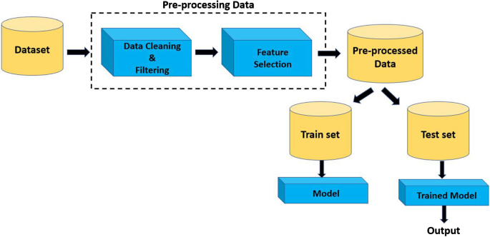
Figure 3: Data preprocessing in telco customers

In the process of developing a customer attrition prediction model, it's crucial to consider various aspects that influence the quality and effectiveness of the model. One of these aspects is feature variety. To build an accurate model, it's important to select a diverse set of features that capture different aspects of customer behavior and characteristics. This includes conducting feature importance analysis to identify which features have the most significant impact on churn prediction. By incorporating a wide range of relevant features, the model can better understand and predict customer attrition.
Another important consideration is data splitting. To train, validate, and test the model effectively, the dataset should be split into distinct subsets. A common practice is to use a split like 70% for training, 15% for validation, and 15% for testing. This ensures that the model is trained on one portion of the data, validated for performance on another, and tested on a separate set to assess its generalization capabilities accurately. Feature engineering and transformation is also crucial. Complex models may require feature engineering to simplify or transform variables for better model performance. For example, creating composite features or scaling features to specific ranges can enhance the model's predictive power. Additionally, when dealing with time-sequence data, it's important to consider time-based features and data splitting strategies that preserve the chronological order of the data, ensuring that the model can effectively capture trends and patterns over time.
Incorporating these considerations into the model development process ensures that the predictive model is robust, accurate, and capable of effectively identifying potential customer attrition within the telecommunications industry.
6.11 Feature Engineering:
- Feature Selection: Identify relevant features (variables) that can influence customer attrition. This may include customer demographics, usage patterns, contract details, customer service interactions, and billing information.
- Feature Engineering: Create new features or transform existing ones if necessary. For example, you might calculate aggregate statistics from usage data, such as average call duration or data usage over a specific period.
6.12 Exploratory Data Analysis (EDA):
Exploratory Data Analysis (EDA) is a crucial first step in understanding the factors influencing customer attrition. Utilizing data visualization techniques such as histograms, scatter plots, and correlation matrices, we can unveil valuable insights into the distribution of data and the intricate relationships between variables. These visualizations can highlight patterns and potential predictors of attrition, such as identifying clusters of customers at higher risk of churning or uncovering trends in customer behavior. Additionally, statistical analysis, including hypothesis tests and regression models, allows us to assess the significance of various features in relation to customer attrition. By quantifying the impact of different variables on attrition, we can prioritize and select the most relevant ones for predictive modeling, ensuring that our models are built on a solid foundation of data-driven insights and increasing their accuracy and effectiveness in mitigating customer churn.

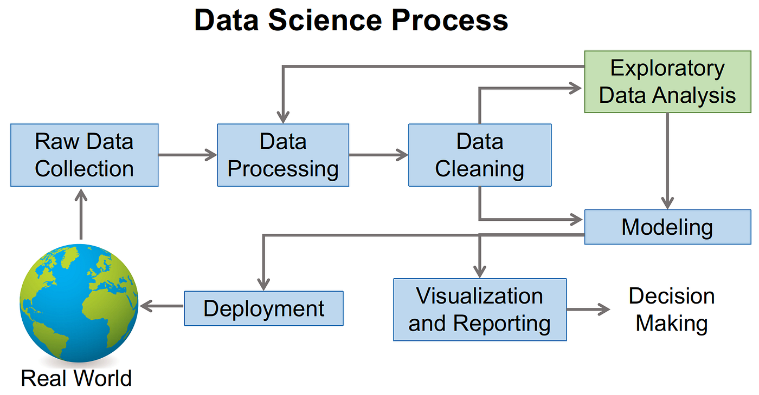

Figure 4: Exploratory Data Analysis (EDA) processing

6.13 Model Selection:
- Classification Algorithms: Choose appropriate machine learning classification algorithms for building the attrition estimation model. Commonly used algorithms include logistic regression, decision trees, random forests, support vector machines, and gradient boosting.
- Model Evaluation: Split the data into training and testing sets to evaluate the performance of different models. Use metrics like accuracy, precision, recall, F1-score, and ROC-AUC to assess model performance.
6.14 Model Development:
- Training the Model: Utilize the training dataset to train the selected attrition estimation model. The model should learn the patterns and relationships within the data that are indicative of customer attrition.
- Hyperparameter Tuning: Fine-tune the model's hyperparameters to optimize its performance. Techniques like grid search or random search can be employed to find the best hyperparameter combinations.
6.15 Model Validation:
- Cross-Validation: Implement cross-validation techniques (e.g., k-fold cross-validation) to ensure the model's robustness and reduce the risk of overfitting.
- Validation on Test Data: Validate the final model on the testing dataset to assess its real-world performance accurately.
6.16 Interpretability and Explainability:
For certain industries, like telcos, it's crucial to have models that are interpretable and explainable. Utilize techniques such as feature importance analysis and model interpretation methods (e.g., SHAP values) to understand how the model makes predictions.

6.17 Deployment and Monitoring:
Once the attrition estimation model is validated, deploy it into the telco's operational environment. Implement monitoring mechanisms to continuously assess its performance over time.
6.18 Retention Strategies:
Based on the attrition predictions, develop tailored retention strategies for customers at risk of churning. These strategies may include personalized offers, targeted marketing campaigns, or enhanced customer service initiatives.
6.19 Feedback Loop:
Establish a feedback loop to continuously improve the attrition estimation model. Incorporate new data and periodically retrain the model to ensure it remains effective in identifying and mitigating customer attrition.
6.20 Documentation and Reporting:
Document the entire methodology, including data sources, preprocessing steps, feature engineering, model selection, and deployment processes. Regularly report the model's performance and insights to relevant stakeholders within the telco company.
6.21 Ethical Considerations:
Ensure that the attrition estimation process adheres to ethical guidelines and privacy regulations. Protect customer data and use it responsibly for the intended purpose.
By following this methodology, telco companies can develop effective customer attrition estimation models that enable proactive churn management, leading to increased customer retention and enhanced business sustainability.

6.22 Logistic Regression
Logistic Regression is a arithmetical and classical for dual responsibilities, wherever the goalmouth is to expect one of two imaginable results or classes, typically denoted as 0 and 1. It is named "logistic" cause it utilizes the logistic function, likewise recognized by way of the shaped purpose, to prototypical the opportunity that a expected participation longs to one of the two modules. In logistic regression, the prototypical calculates the odds or prospect of the happening happening and maps to a value tween 0 and 1. possibility is then to variety estimates, typically with a verge of 0.5; values greater than the verge are classified as one class, while values less than the verge are confidential as the supplementary. Logistic regression is widely in several fields, healthcare, finance, and marketing, for responsibilities like spam detection, credit scoring, and medical diagnosis, among others.
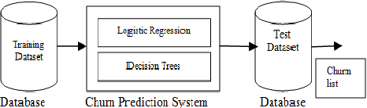
Figure 5: Logistic Regression using customer attrition

6.23 Support Vector Classifier
A Support Vector Classifier (SVC), also identified as a Support Vector (SVM) with a linear kernel, is a controlled algorithm for responsibilities. It longs to the family of discriminative and is principally actual in dual, where the goal is to distinct information points into two modules or sorts. The SVC the whole kit and caboodle by discovery a hyperplane that make the most of the border of departure tween the two modules in the feature interplanetary. hyperplane is nominated in such a way that it is contiguous to some data opinions from each class, called sustenance vectors. SVC can holder both linearly distinguishable and non-linearly distinguishable datasets through the use of countless kernel occupations, which convert the information into a advanced-dimensional interplanetary to enable separation. The primary objective of an SVC is to treasure the ideal hyperplane that not only splits the data but also oversimplifies well to classify new, unseen data accurately. SVCs are widely in a range of submissions, image, text, and, in the context of Trades prediction, to classify as churners or non-churners based on their features and behaviors.
6.24 Decision Tree Classifier
A Decision Tree Classifier is a supervised algorithm for both and regression responsibilities. It creates a tree-like model of decisions and their possible consequences. In the context of, it is designed to predict the class or category of a given input by recursively excruciating the dataset into subsets based on the standards of input features. At each internal node of the tree, a decision or test is made on a feature, and the data is partitioned into branches that correspond to different outcomes of the test. The progression continues until a leaf node is reached, which represents the predicted class all. Decision trees are interpretable, laidback to visualize, and are widely for tasks like customer Trades prediction, spam detection, and medical diagnosis, among others.
6.25 KNN Classifier

The k-Nearest Neighbors (KNN) Classifier is a supervised procedure for responsibilities. In KNN, an object is confidential by a mainstream division of its fellow citizen, with the objecting allocated to the period furthermost mutual between its k-nearest neighbors. It operates on the principle of similarity, where information arguments that are closer to each other in feature interplanetary are more likely to long to the same class. KNN does not variety conventions around the fundamental information circulation, making it a non-parametric and versatile algorithm. It is commonly for tasks like outline acknowledgement, image, and commendation systems, where the relationship tween information arguments can inferred from their proximity in the feature space. The choice of the limitation k (the number of nationals to consider) can significantly impact the procedure's performance and generalization.

VII. IMPLEMENTATION
To implement customer attrition estimation in telcos, begin by gathering and preprocessing relevant customer data, including demographics, usage patterns, and billing information. Next, develop predictive models using machine learning algorithms, such as logistic regression, decision trees, or neural networks, to identify factors influencing customer churn. Train and validate these models using historical data and evaluation metrics. Once the model is fine-tuned, deploy it in a real-time or periodic monitoring system to predict potential churners. Regularly update the model with new data and use its insights to create targeted customer retention strategies, such as personalized offers and proactive customer support, to reduce attrition and enhance customer satisfaction. This implementation ensures telcos can proactively address customer churn and optimize their operations.
7.1 Importing Libraries
When estimating customer attrition in telcos, it's essential to import key libraries to facilitate data analysis and predictive modeling. In Python, you would typically import libraries like Pandas for data manipulation, NumPy for numerical operations, Scikit-Learn (sklearn) for machine learning algorithms, Seaborn and Matplotlib for data visualization. These libraries collectively empower you to load, clean, and preprocess customer data efficiently with Pandas, perform data analysis and predictive modeling with Scikit-Learn, handle numerical computations with NumPy, and create informative visualizations using Seaborn and Matplotlib. By integrating these libraries, you can conduct a comprehensive analysis of telco customer data and build predictive models to estimate and mitigate customer attrition effectively.
CODING:
import pandas as pd
import sklearn
import numpy as np
import seaborn as sns
import matplotlib
import matplotlib.pyplot as plt
%matplotlib inline
7.2 Importing Dataset
Importing a dataset for telco, or data study involves the procedure of charging and incorporating the data into your analysis environment, typically a software or program design tool like Python, R, or a spreadsheet program. step is essential as it provides the foundation for all subsequent data exploration, cleaning, and modeling tasks in telco-related projects. The dataset typically contains about, their usage patterns, billing details, customer service communications, and whether they have Churned or not. By importing the telco dataset, forecasters and data scientists gain access to the raw information required for predictive modeling and business intuitions, enabling them to uncover decorations, trends, and valuable that can help telecom corporations optimize customer retention strategies and make data-driven decisions.
CODING:
df=pd.read_csv('C:/Users/jansi/OneDrive/Documents/WA_Fn-UseC_-Telco-Customer-Churn.csv')
df.shape
OUTPUT:
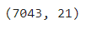

7.3 Exploratory Data Analysis
Exploratory Data Analysis (EDA) for a telco dataset includes the methodical procedure of imagining, succinct, and empathetic the key physiognomies and decorations in the interior the data. It aims to uncover appreciated intuitions that can inform succeeding investigates and modeling efforts for tasks like customer churn calculation. During EDA, forecasters examine abundant topographies of the telco data, such as client demographics, usage behavior, billing information, and more. They employ procedures like data imagining, arithmetical summaries, and correlation investigation to classify inclinations, incongruities, and probable associations amongst variables. EDA not only helps in categorizing important features for modeling but also assists in addressing data excellence issues, misplaced values, and outliers, ensuring that the data is well-prepared for accurate predictive modeling and unlawful professional insights within the telecommunications industry.
CODING:
df.head(5)
OUTPUT:
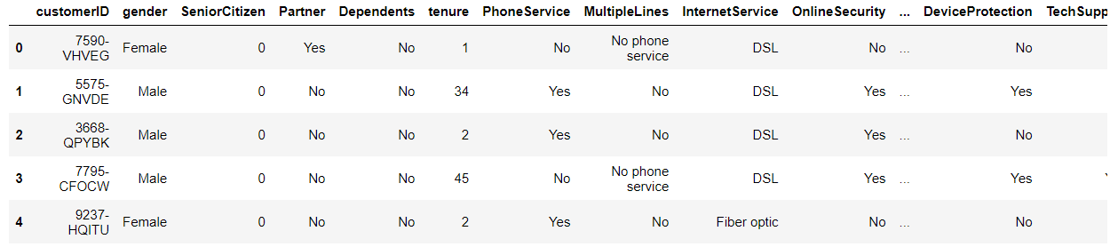
df.tail()
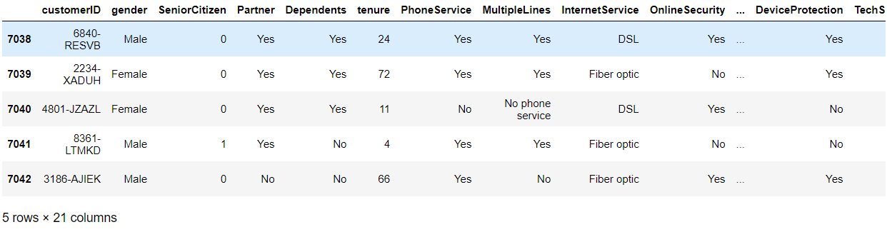
df.dtypes
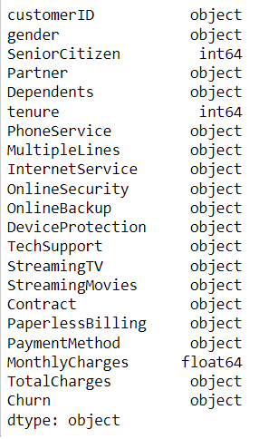
df.columns

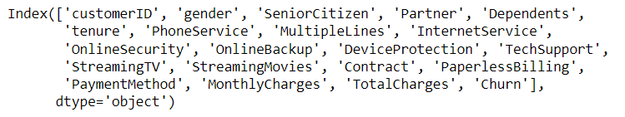

df.info()
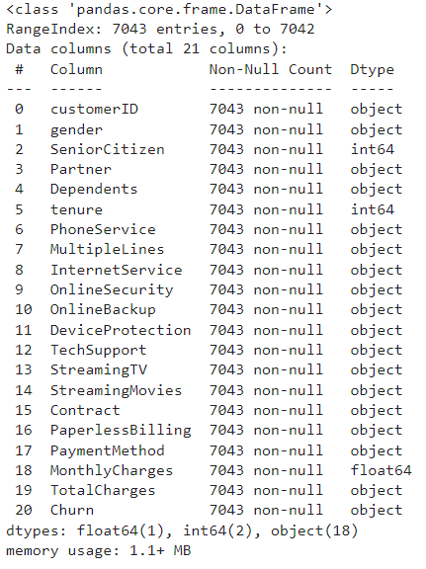
df.isnull().sum()

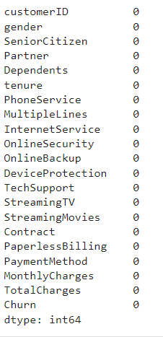
7.4 Basic data cleaning
Basic data cleaning is a crucial step in customer attrition estimation for telcos. It involves several key tasks such as handling missing values by imputation or removal, identifying and addressing duplicate records, checking for outliers that might skew the analysis, and converting data types as needed. Additionally, it's essential to perform consistency checks to rectify inconsistencies or errors in the data, like ensuring uniform date formats or dealing with typos and naming inconsistencies. Properly cleaned data sets the foundation for accurate and reliable customer attrition modeling and analysis, ensuring that subsequent predictions are based on high-quality data.
CODING:
df['TotalCharges'] = pd.to_numeric(df['TotalCharges'],errors = 'coerce')

categorical_features = [
"gender",
"SeniorCitizen",
"Partner",
"Dependents",
"PhoneService",
"MultipleLines",
"InternetService",
"OnlineSecurity",
"OnlineBackup",
"DeviceProtection",
"TechSupport",
"StreamingTV",
"StreamingMovies",
"Contract",
"PaperlessBilling",
"PaymentMethod",
]
numerical_features = ["tenure", "MonthlyCharges", "TotalCharges"]
target = "Churn"
df.skew(numeric_only= True)

OUTPUT:

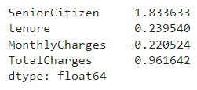

CODING:

df.corr(numeric_only= True)

OUTPUT:
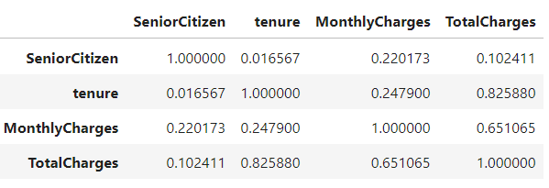
7.3 Feature distribution
To look for outliers and associate feature circulations with the goal variable, we plot disseminations for both numerical and categorical characteristics.

Numerical features distribution
The use of arithmetical summarizing (mean, ordinary deviation, etc.) makes it awkward to commercial outliers cause they don't display distributional spikes or forms. That is why we employ histograms.
CODING:
df[numerical_features].describe()

OUTPUT:
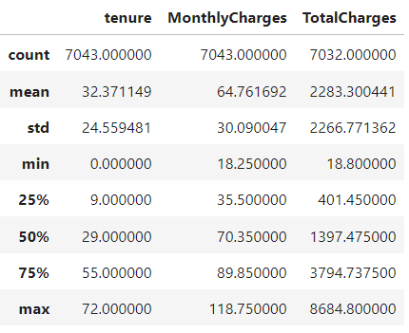

CODING:
df[numerical_features].hist(bins=30, figsize=(10, 7))
OUTPUT:
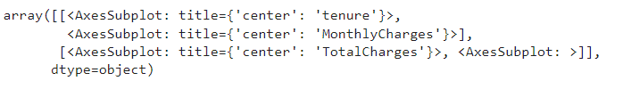
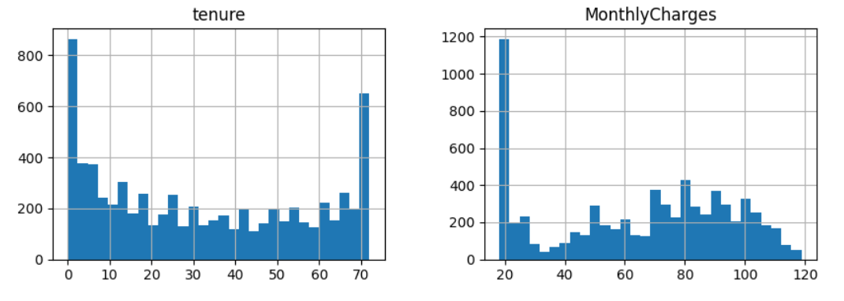
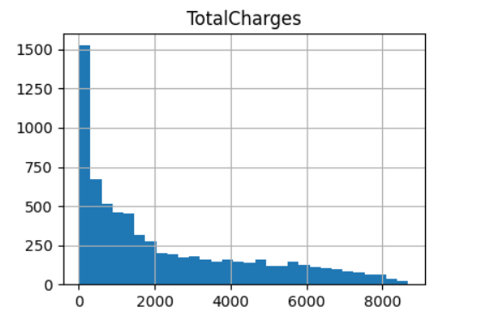
Figure 6: Numerical Feature distribution
CODING:
fig, ax = plt.subplots(1, 3, figsize=(14, 4))
df[df.Churn == "No"][numerical_features].hist(bins=30, color="blue", alpha=0.5, ax=ax)
df[df.Churn == "Yes"][numerical_features].hist(bins=30, color="red", alpha=0.5, ax=ax)
OUTPUT:
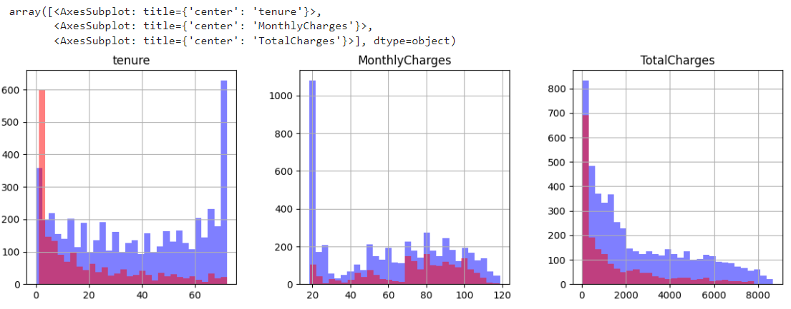
Figure 7: Numerical features in relation to the target variable
Categorical feature distribution

Categorical feature circulation in telco client Trades forecast refers to the pattern or spread of non-numeric attributes (e.g., customer gender, subscription plan, contract type) within the dataset. It involves understanding how categorical variables are distributed across different groupings or classes, which is crucial for identifying potential factors influencing customer Trades and for creating effective predictive. Evaluating categorical feature distribution helps in recognizing trends and relationships that may impact customer behavior and informs feature engineering and selection processes in Trades prediction.
CODING:
ROWS, COLS = 4, 4
fig, ax = plt.subplots(ROWS,COLS, figsize=(19,19))
row, col = 0, 0,
for i, categorical_feature in enumerate(categorical_features):
if col == COLS - 1:
row += 1
col = i % COLS
df[categorical_feature].value_counts().plot(kind='bar', ax=ax[row,col]).set_title(categorical_feature)

OUTPUT:
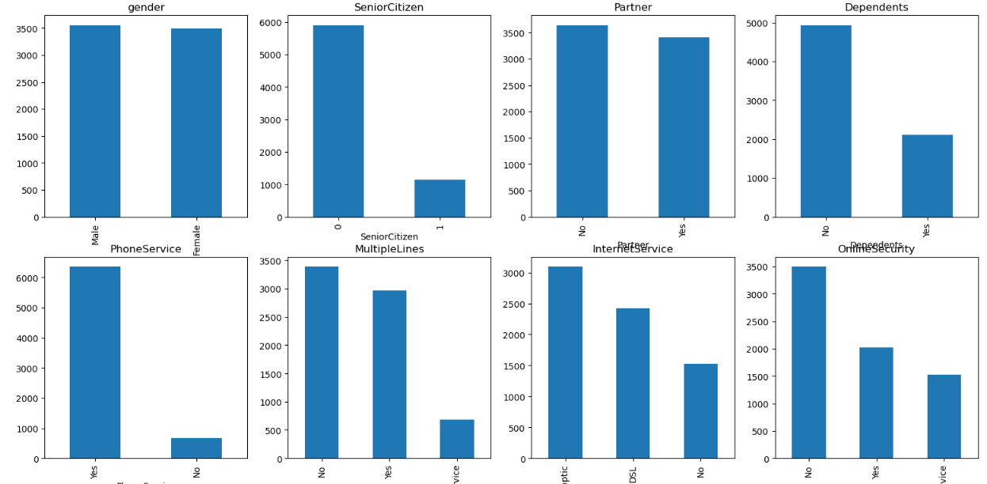
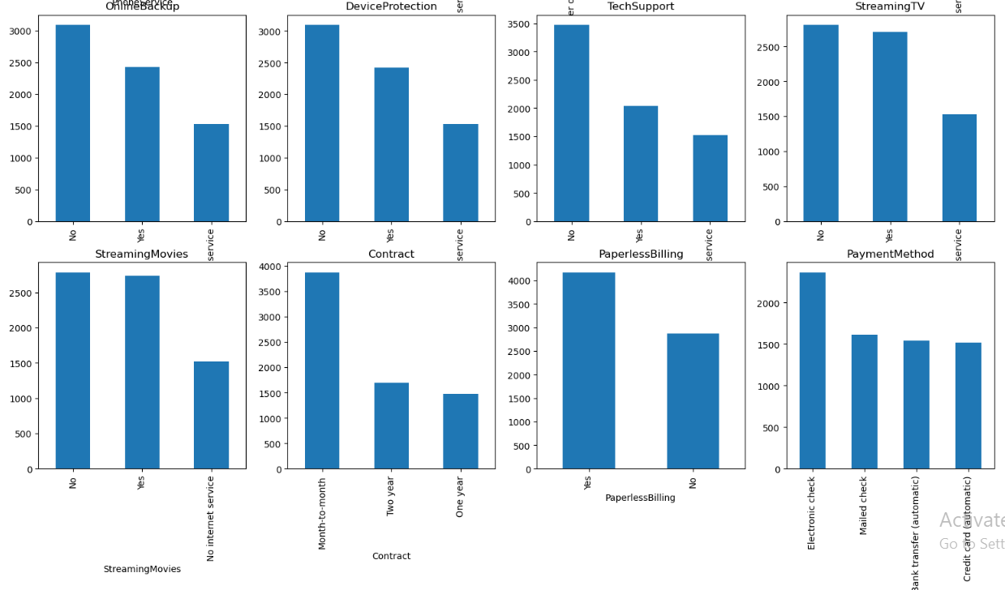
Figure 8: Categorical feature circulation in telco customer
CODING:
feature = 'Contract'
fig, ax = plt.subplots(1, 2, figsize=(12, 4))
df[df.Churn == "No"][feature].value_counts().plot(kind='bar', ax=ax[0]).set_title('not churned')
df[df.Churn == "Yes"][feature].value_counts().plot(kind='bar', ax=ax[1]).set_title('churned')
OUTPUT:
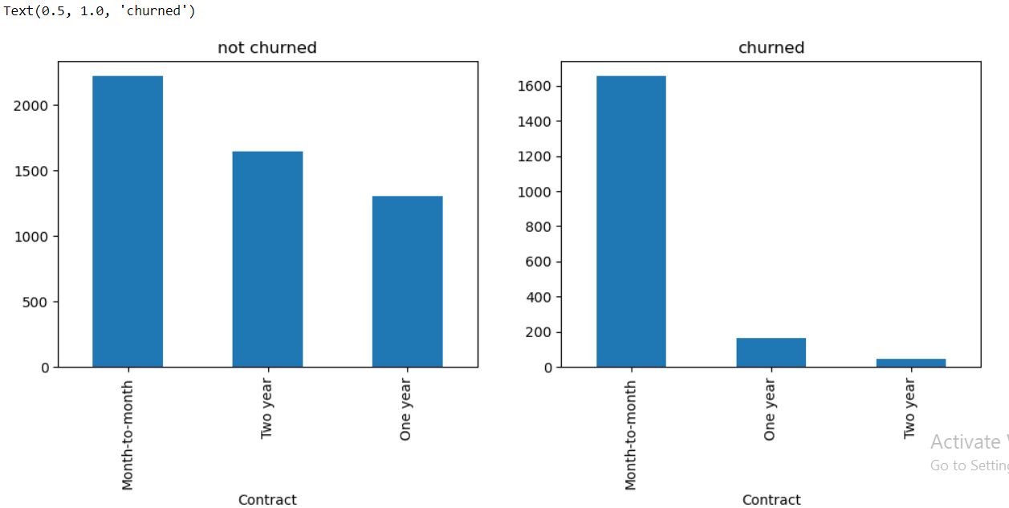
Figure 9: Telco customers churned or not churned

Target variable distribution
Target variable circulation reveals that there are significantly more non-Churned users than Churned users, indicating that the problem we are facing is uneven. The model would realize high accurateness cause it would mostly anticipate users in the majority class—those who, in our case, did not Trades.
There are a few chattels we can take to lessen the impression of an unbalanced dataset:
- Re-sample the data,
- get additional samples,
- utilize recollection and precision as criteria for exactness.
CODING:
df[target].value_counts().plot(kind='bar').set_title('churned')
OUTPUT:
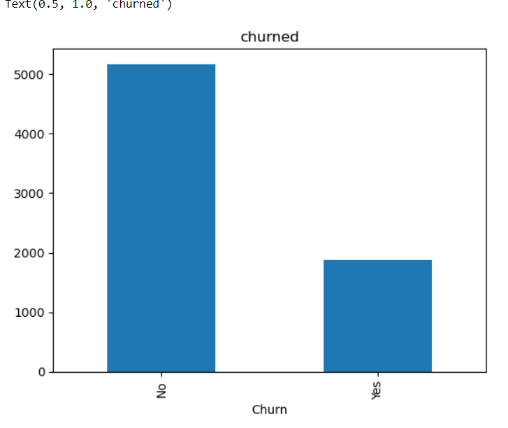
Figure 10: Target variable circulation non-churned and churned

7.4 Outliers Analysis with IQR Method:
Outliers analysis the Interquartile Range (IQR) technique in telco customer Trades prediction is a vital component of the project methodology. In context, outliers are information ideas that diverge suggestively from the typical patterns within the dataset, and identifying them is crucial for ensuring the exactness and robustness of predictive. The IQR method involves manipulative the interquartile range, which characterizes the banquet of information tween the primary quartile (25th percentile) and the third quartile (75th percentile) of a variable's distribution. Information points lying low the lower bound (Q1 - 1.5 * IQR) or above the upper bound (Q3 + 1.5 * IQR) are measured outliers. By applying the IQR process, we can systematically perceive and potentially address outliers in telco client information, which may include anomalies in usage patterns, billing, or other variables.
process enhances the superiority and consistency of the data for subsequent investigation and model building, ultimately contributing to more accurate and actionable insights for Trades prediction.
CODING:
x = ['tenure','MonthlyCharges']
def count_outliers(data,col):
q1 = data[col].quantile(0.25,interpolation='nearest')
q2 = data[col].quantile(0.5,interpolation='nearest')
q3 = data[col].quantile(0.75,interpolation='nearest')
q4 = data[col].quantile(1,interpolation='nearest')
IQR = q3 -q1
global LLP
global ULP
LLP = q1 - 1.5*IQR
ULP = q3 + 1.5*IQR
if data[col].min() > LLP and data[col].max() < ULP:
print("No outliers in",i)
else:
print("There are outliers in",i)
x = data[data[col]<LLP][col].size
y = data[data[col]>ULP][col].size
a.append(i)
print('Count of outliers are:',x+y)
global a
a = []
for i in x:
count_outliers(df,i)

OUTPUT:
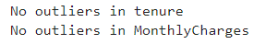

7.6 On Hot Encoding
One-hot encoding is a crucial preprocessing step in customer attrition estimation for telcos. It is used to convert categorical variables, such as contract types or payment methods, into a binary format that machine learning models can understand. Each unique category becomes a binary column, with '1' indicating the presence and '0' for absence. This process helps prevent model misinterpretation of ordinal data and allows for more accurate predictions, improving the overall performance of attrition models in telco analytics.
CODING:
df1=pd.get_dummies(data=df,columns=['gender', 'Partner', 'Dependents',
'PhoneService', 'MultipleLines', 'InternetService', 'OnlineSecurity',
'OnlineBackup', 'DeviceProtection', 'TechSupport', 'StreamingTV',
'StreamingMovies', 'Contract', 'PaperlessBilling', 'PaymentMethod', 'Churn'], drop_first=True)
df1.head()

OUTPUT:
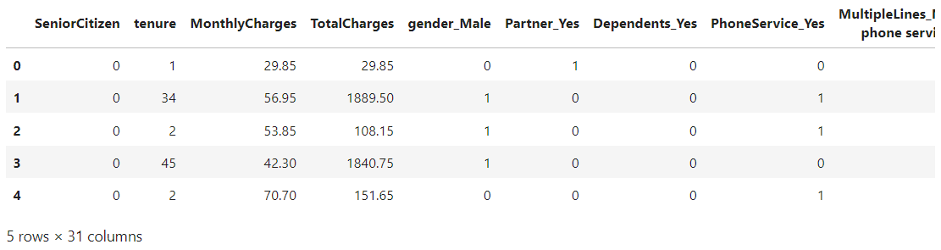
7.5 Feature scaling
Feature scaling in telco customer Trades prediction refers to the procedure of homogenizing or homogenizing the numerical topographies within the dataset to ensure they partake comparable balances or parts is done to avert firm features from governing the modeling process due to their larger magnitude, making it fair for all features to donate similarly to the predictive perfect. Mutual include Min-Max mounting (mounting features to a specified variety, typically [0, 1]) and z-score calibration (scaling features to partake a mean of 0 and a average unconventionality of 1). Feature scaling is indispensable to enhance the presentation of algorithms and advance the accuracy of Trades prediction.
CODING:
from sklearn.preprocessing import StandardScaler
scaler = StandardScaler()
scaler.fit(df1.drop(['Churn_Yes'],axis = 1))
scaled_features = scaler.transform(df1.drop('Churn_Yes',axis = 1))
7.6 Feature Selection
Feature selection in telco customer Trades estimate is the procedure of picking a subset of the maximum and enlightening features (variables or qualities) from the available evidence. It aims to improve model presentation, reduce overfitting, and enhance model interpretability by absorbent only those features that have a momentous impact on client Trades while discarding ir or terminated ones. selection of features helps streamline the modeling process, making it more efficient and effective in identifying patterns and trends associated with client Trades.
CODING:
from sklearn.model_selection import train_test_split
X = scaled_features
Y = df1['Churn_Yes']
X_train,X_test,Y_train,Y_test = train_test_split(X,Y,test_size = 0.3,random_state=44)

7.7 Prediction Logistic Regression
The adjustable "Trades" will therefore tell us whether or not a specific client has Churned, making it the target variable in situation. It is a binary variable where 1 entitles that a client has left and 0 designates that they have not. We need to forecast if a specific client will migrate to added telecom provider or not 21 prognosticator variables.

CODING:
from sklearn.linear_model import LogisticRegression
from sklearn.metrics import classification_report,accuracy_score ,confusion_matrix
logmodel = LogisticRegression()
logmodel.fit(X_train,Y_train)
predLR = logmodel.predict(X_test)
predLR
Y_test
OUTPUT:
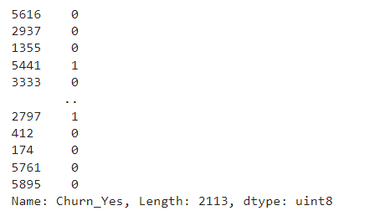
CODING:
print(classification_report(Y_test, predLR))
OUTPUT:
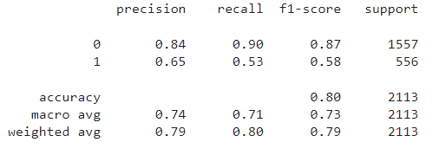
CODING:
report = classification_report(Y_test, predLR, target_names=['Churn_No', 'Churn_Yes'])
lines = report.split('\n')
parts = [line.split() for line in lines[2:-5]]
class_metrics = dict()
for part in parts:
class_metrics[part[0]] = {'precision': float(part[1]), 'recall': float(part[2]), 'f1-score': float(part[3]), 'support': int(part[4])}
fig, ax = plt.subplots(1, 4, figsize=(12, 4))
metrics = ['precision', 'recall', 'f1-score', 'support']
for i, metric in enumerate(metrics):
ax[i].bar(class_metrics.keys(), [class_metrics[key][metric] for key in class_metrics.keys()])
ax[i].set_title(metric)
plt.show()
OUTPUT:
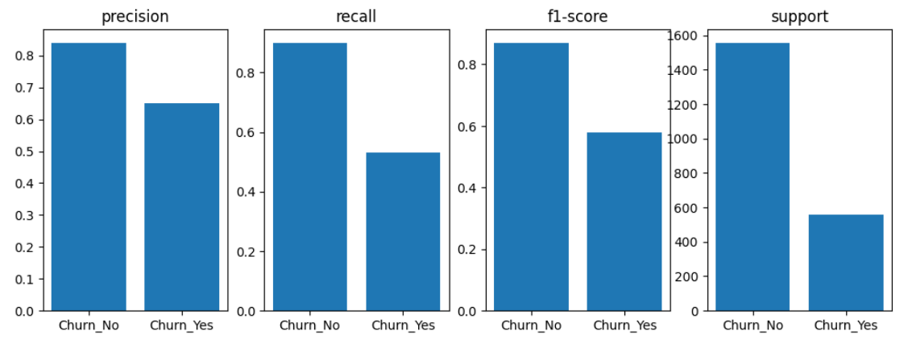
CODING:
confusion_matrix_LR = confusion_matrix(Y_test, predLR)
plt.matshow(confusion_matrix(Y_test, predLR))
plt.xlabel('Predicted Class')
plt.ylabel('Actual Class')
for i in range(2):
for j in range(2):
plt.text(j, i, confusion_matrix_LR[i, j], ha='center', va='center')
plt.xticks([0, 1], ["Not Churned", "Churned"])
plt.yticks([0, 1], ["Not Churned", "Churned"])
plt.show()

OUTPUT:
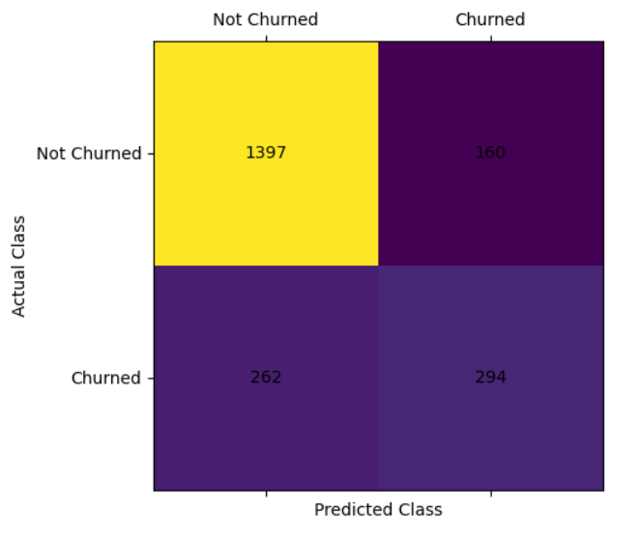
Figure 11: Prediction Logistic Regression

CODING:
logmodel.score(X_train, Y_train)
accuracy_score(Y_test, predLR)
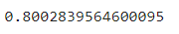

7.8 Prediction Support Vector Classifier
The process described involves support vector machines (SVMs), a popular machine learning algorithm used for classification tasks. In SVM, information and opinions are represented as data points in a multidimensional space. The algorithm aims to find a hyperplane, which is like a decision boundary, that effectively separates these data points into different categories or tags. In simpler cases with two dimensions, this hyperplane appears as a line, and in more complex scenarios, it becomes a multidimensional surface. The goal is to position this hyperplane in a way that maximizes the margin between the data points of different categories, leading to accurate classification. SVMs are known for their ability to create robust and effective classifiers in various domains.
CODING:
from sklearn.svm import SVC
svc = SVC()
svc.fit(X_train, Y_train)
y_pred_svc = svc.predict(X_test)
print(classification_report(Y_test, y_pred_svc))

OUTPUT:
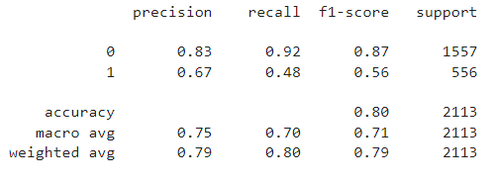

CODING:

confusion_matrix_svc = confusion_matrix(Y_test, y_pred_svc)
plt.matshow(confusion_matrix_svc)
plt.xlabel('Predicted Class')
plt.ylabel('Actual Class')
for i in range(2):
for j in range(2):
plt.text(j, i, confusion_matrix_svc[i, j], ha='center', va='center')
plt.xticks([0, 1], ["Not Churned", "Churned"])
plt.yticks([0, 1], ["Not Churned", "Churned"])
plt.show()

OUTPUT:
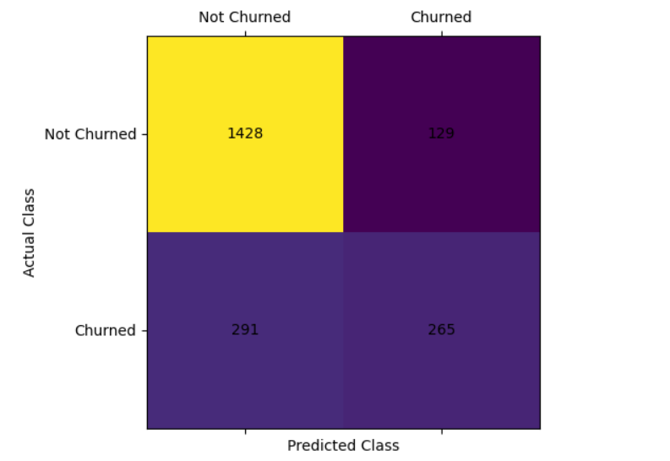
Figure 12: Prediction Support Vector Classifier
svc.score(X_train,Y_train)
accuracy_score(Y_test, y_pred_svc)
7.9 Prediction Decision Tree Classifier
A Decision Tree is a widespread algorithm for responsibilities. It characterizes a flowchart-like tree assembly where individually internal lump characterizes a choice or trial on a feature, each subdivision resembles to an consequence of the trial, and each leaf node designates a lecture tag (in case, Trades or no-Trades). Decision Trees recursively fragmented the material into subdivisions founded on the most informative features, manufacture them suitable for responsibilities.
CODING:
from sklearn.tree import DecisionTreeClassifier
dtc = DecisionTreeClassifier()
dtc.fit(X_train, Y_train)
y_pred_dtc = dtc.predict(X_test)
print(classification_report(Y_test, y_pred_dtc))

OUTPUT:
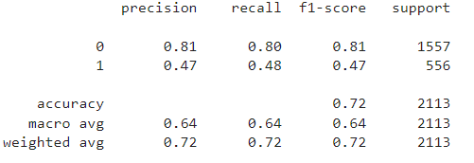

CODING:
confusion_matrix_dtc = confusion_matrix(Y_test, y_pred_dtc)
plt.matshow(confusion_matrix_dtc)
plt.xlabel('Predicted Class')
plt.ylabel('Actual Class')
for i in range(2):
for j in range(2):
plt.text(j, i, confusion_matrix_dtc[i, j], ha='center', va='center')
plt.xticks([0, 1], ["Not Churned", "Churned"])
plt.yticks([0, 1], ["Not Churned", "Churned"])
plt.show()

OUTPUT:
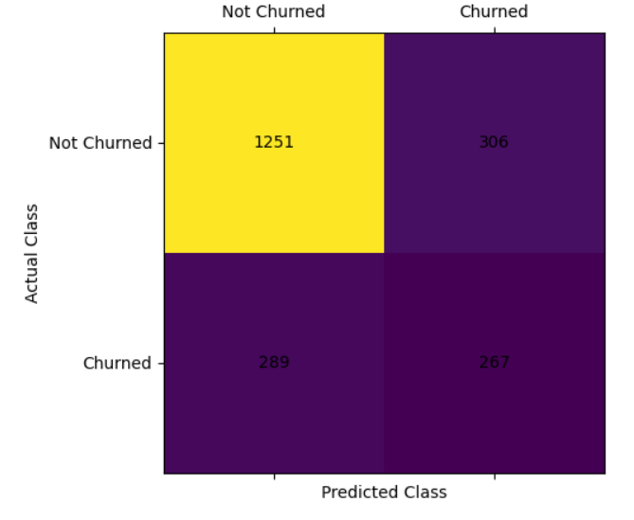
Figure 13: Prediction Decision Tree Classifier
dtc.score(X_train,Y_train)
accuracy_score(Y_test, y_pred_dtc)

7.10 Prediction KNN Classifier
KNN is a algorithm for responsibilities. It activates on the opinion of resemblance, anywhere it categorizes a information idea by beholding at the session tags of its K nearest neighbors in the feature space. In the context of telco Trades prediction, KNN assesses the comparation tween a customer and their neighbors to determine if they are likely to Trades or not.
CODING:
from sklearn.neighbors import KNeighborsClassifier
knn = KNeighborsClassifier(n_neighbors = 30)
knn.fit(X_train,Y_train)
pred_knn = knn.predict(X_test)
error_rate= []
for i in range(1,40):
knn = KNeighborsClassifier(n_neighbors = i)
knn.fit(X_train,Y_train)
pred_i = knn.predict(X_test)
error_rate.append(np.mean(pred_i != Y_test))
plt.figure(figsize = (10,6))
plt.plot(range(1,40),error_rate,color = 'blue',linestyle = '--',marker = 'o',markerfacecolor='red',markersize = 10)
plt.title('Error Rate vs K')
plt.xlabel('K')
plt.ylabel('Error Rate')
OUTPUT:

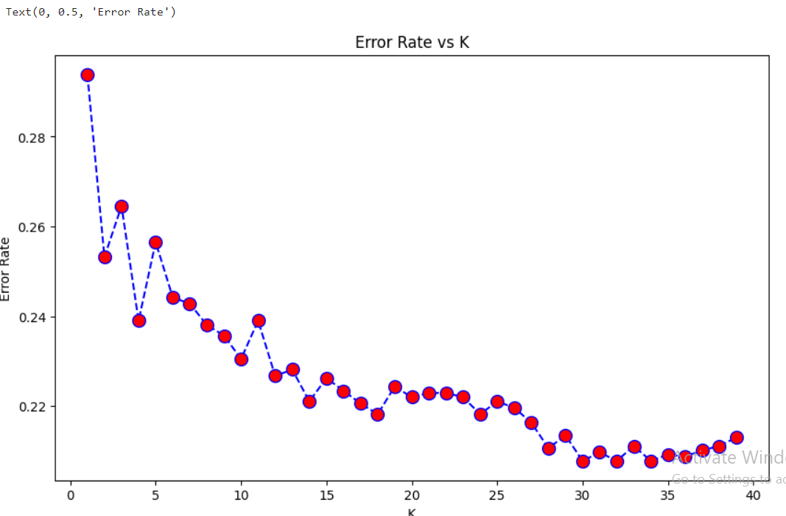

CODING:
print(classification_report(Y_test,pred_knn))

OUTPUT:
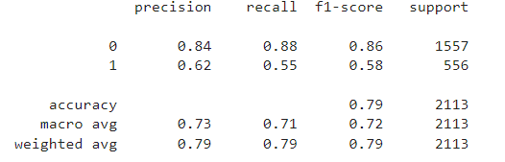
CODING:

confusion_matrix_knn = confusion_matrix(Y_test,pred_knn)

plt.matshow(confusion_matrix_knn)

plt.xlabel('Predicted Class')
plt.ylabel('Actual Class')

for i in range(2):
for j in range(2):
plt.text(j, i, confusion_matrix_knn[i, j], ha='center', va='center')

plt.xticks([0, 1], ["Not Churned", "Churned"])
plt.yticks([0, 1], ["Not Churned", "Churned"])
plt.show()

OUTPUT:

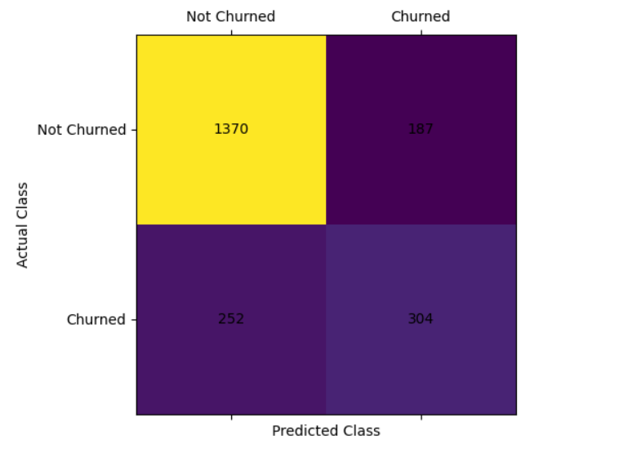

Figure 14: Prediction KNN Classifier

knn.score(X_train,Y_train)

accuracy_score(Y_test, pred_knn)

TABULATION OF MODEL EVALUATION CLASSIFIER FOR EACH MODEL

MODEL_NAME | ACCURACY_SCORE
Logistic Regression | 0.8002839564600095
Support Vector Classifier | 0.8012304779933743
Decision Tree Classifier | 0.718409843823947
KNN Classifier | 0.792238523426408

Table 1 : Models Name And Their Accuracy Scores
The greatest value of the Support Vector Classifier (SVC) for the model is 0.8012304779933743 when we compare these Accuracy Scores for each model. Consequently, we determined that the Support Vector Classifier (SVC) fit our data the best.

VIII. CONCLUSION
Data preprocessing in telco client Trades prediction denotes to the set of responsibilities and applied to the raw client information fore it is for investigation or demonstrating. progression contains scrubbing, transmuting, and organizing the information to ensure it is exact, comprehensive, and suitable for extrapolative demonstrating. Information preprocessing aims to augment the excellence of the dataset, making it more effective for classifying decorations and customer Trades accurately. Mutual information preprocessing steps in context include conduct misplaced values, encoding uncompromising variables, clambering arithmetic features, and addressing outliers, among others. The eventual goal of information preprocessing is to prepare the data so that algorithms can applied effectively to predict customer Trades and assist telecom companies in customer retention efforts.

REFERENCE
[1] V. Lazarov and M. Capota, ‘‘Trades prediction,’’ Bus. Anal. Course, TUM Comput. Sci, Technische Univ. München, Tech. Rep., 2007. [Online]. Available: http://citeseerx.ist.psu.edu/viewdoc/download? doi=10.1.1.462.7201&rep=rep1&type=pdf.
[2] S. A. Qureshi, A. S. Rehman, A. M. Qamar, A. Kamal, and A. Rehman, ‘‘Telecommunication subscrirs’ Trades prediction model ,’’ in Proc. 8th Int. Conf. Digit. Inf. Manage., Sep. 2013, pp. 131–136
[3] F. Castanedo, Deep to Predict Customer Trades in a Mobile Telecommunication Network (2014)
[4] J. Hadden, A. Tiwari, R. Roy, D. Ruta, Computer assisted customer Trades management: state-of-the-art and upcoming trends. Comput. Oper. Res. 34, 2902–2917 (2007). https://doi.org/10.1016/j.cor.2005.11.007
[5] C. Kirui, L. Hong, W. Cheruiyot, H. Kirui, customer Trades in mobile telephony probabilistic classifiers in data mining. Int. J. Comput. Sci. Issues. 10, 165–172 (2013)
[6] S.A. Qureshi, A.S. Rehman, A.M. Qamar, A. Kamal, A. Rehman, Telecommunication subscribers’ Trades prediction model , in: 2013 Eighth International Conference on Digital Management (ICDIM), IEEE, 2013, pp. 131–136.
[7] Adhikary, D.D., & Gupta, D. (2021). Applying over 100 classifiers for Trades prediction in telecom companies. Multimedia Tools and Applications, 80 (28), 35,123–35,144. https://doi.org/10.1007/s11042-020-09658-z.

[8] "How Costly Is Customer Trades in the Telecom ?", The European Business Review, Aug 2020, [online] Available: https://www.europeanbusinessreview.com/how-costly-is-customer-Trades-in-the-telecom-/.
[9] S.A. Qureshi, A.S. Rehman, A.M. Qamar, A. Kamal, A. Rehman, Telecommunication subscribers’ Trades prediction model, in: 2013 Eighth International Conference on Digital Management (ICDIM), IEEE, 2013, pp. 131–136.
[10] S. Gürsoy, U. Tug˘ba, Customer Trades analysis in telecommunication sector, J. School Bus. Admin. Istanbul Univ. 39 (1) (2010) 35–49.
[11] Chen J, Ching RKH (2007). In: Ralph H. Sprague (ed.), The Effects of Mobile Customer Relationship Management on Customer Loyalty: Brand Image does Matter, being a proceedings of the 40th Hawaii international Conference on System Service. p.151.
[12] Gan C, Cohen D, Clemes M, Chong E (2006). A Survey of Customer Retention in the New Zealand Banking Industry: Banks and Bank Syst., 1(4): 83-99.
[13] Wong A, Sohal A (2003). Service quality and customer loyalty; perspectives on two levels of retail relationships. J. Serv. Mark., 17(5): 495 - 513.
[14] Kim HS, Yoon CH (2004). Determinants of subscriber churn and customer loyalty in the Korean mobile telephony market. Telecomm. Policy, 28(6): 751-765.
[15] Khan AA, Jamwel S, Sepehri MM (2010). Applying Data Mining to Customer Churn Prediction in an Internet Service Provider. Int. J. Comput. Appl., 9(7): 44.
[16] Lu, Junxiang, Detecting Churn Triggers for Early Life Customers in the Telecommunications Industry – An Applications of Interactive Tree Training, Proceedings of the 2nd Data Mining Conference of DiaMondSUG 2001, Chicago, IL, 2001.
[17] Lu, Junxiang, Predicting Customer Churn in the Telecommunications Industry – An Application of Survival Analysis Techniques, Proceedings of the 27th Annual SAS Users Group International Conference, Cary, NC: SAS Institute Inc., 2002.
[18] Smith Tyler and Besa Smith, Survival Analysis and the Application of Cox’s Proportional Hazard Modeling Using SAS, Proceedings of the 26th Annual SAS Users Group International Conference, Cary, NC: SAS Institute Inc., 2001.
[19] Rud, Olivia Parr, Data Mining Cookbook, New York: John Wiley & Sons, 2001.
[20] Ahn, J., Han, S., and Yung-Seop, L., ‘Customer Churn Analysis: Churn Determinants and Mediation Effects of Partial Defection in the Korean Mobile Telecommunications Service Industry’, Telecommunications Policy, 30, 2016, 552-568.
[21] Blattberg, R., Malthouse, E., and Neslin, S., ‘Customer Lifetime Value: Empircal Generalizations and Some Conceptual Questions’, Journal of Interactive Marketing, 23, 2009, 157-168.
[22] Burez, J. and Van den Poel, D., ‘CRM at a pay-tv company: Using analytical models to reduce customer attrition by targeted marketing for subscription services’, Expert Systems with Applications, 32, 2007, 277-288.
[23] Gopal, R. K., & Meher, S. K., ‘Customer churn time prediction in mobile telecommunication industry using ordinal regression’, In Pacific-Asia Conference on Knowledge Discovery and Data Mining (pp. 884-889). 2008, Springer Berlin Heidelberg.
[24] Zhang, Y., Liang, R., Li, Y., Zhang, Y., and Berry, M., ‘Behavior-based telecommunications churn prediction with neural network approach’, 2011 International Symposium on Computer Science and Society. DOI: 10.1109/ISCCS, 2011, 89. 2011.
[25] Oujezsky, V., Horvath, T., and Skorpil, V., ‘Botnet C&C traffic and flow using survival analysis’, International Journal of Advances in Telecommunications Electro techniques, Signals and Systems. 6(1), 2017.
[26] Owczarczuk, M., ‘Churn Models for Prepaid Customers in the Cellular Telecommunication Industry using Large Data Marts’, Expert Systems with Applications, 37, 2010, 4710-4712.
[27] Wei, C. and Chiu, I., ‘Turning telecommunications call details to churn prediction: A data mining approach’, Expert Systems with Applications, 23, 2002, 103-112.
[28] Tsai, C. and Lu, Y., ‘Customer churn prediction by hybrid neural networks’, Expert Systems with Applications, 36, 2009, 12547-12553.
[29] Buckinx, W. and Van den Poel, D., ‘Customer base analysis: partial defection of behaviorally loyal clients in a non-contractual FMCG retail setting’, European Journal of Operational Research, 164, 2005, 252-268.
[30] Coussement, K. and Van den Poel, D., ‘Churn prediction in subscription services: An application of support vector machines while comparing two parameter-selection techniques’, Expert Systems with Applications, 34, 2008, 313-327.
Plagiarism Report:








